**Operational Descriptions:**



Upon opening the app, the launch screen will initially and briefly appear as simply the background color, followed shortly thereafter by incorporation of an animated transition of the logo (like letters running out onto the screen). After the logo has loaded, a simultaneous fade-in animation of the buttons presenting the user with the option to select “returning user?” or “new user?” will load. Selecting “returning user?” will direct the user to the “Registration” screen, as will “new user?” to the “Sign-In” screen. The option to return to the launch screen is available in the upper, left-hand corners of the “Registration” and “Sign-In” screens. No other screens will utilize animated transitions following the launch screen.

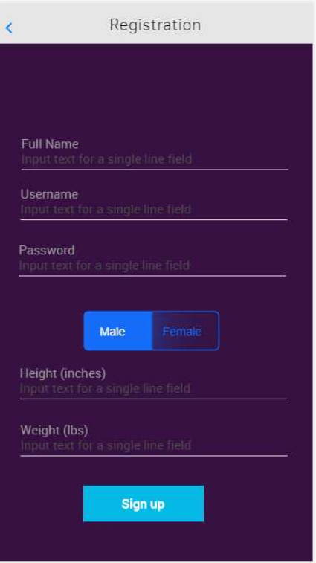

On the registration screen, the user is expected to fill out all fields (pop-up keyboard appears when text field area selected, and disappears when background selected or “Enter” key pressed), else the “Sign up” button will not be enabled. A toggle switch for selecting one’s gender is available (non-binary genders may be incorporated in Alpha Release or later). The “Full Name” text field will only accept ASCII values 64-90 and 97-122 (i.e. upper and lower case letters). “Username” and “Password” text fields will accept letters, numbers, and standard keyboard punctuation/characters, while “Height” and “Weight” will only accept integer values and no other characters. If all fields are completed and the “Sign up” button is selected, but the incorrect ASCII values were utilized, red text will appear below the incorrectly filled out text fields prompting the user what type of input is acceptable.

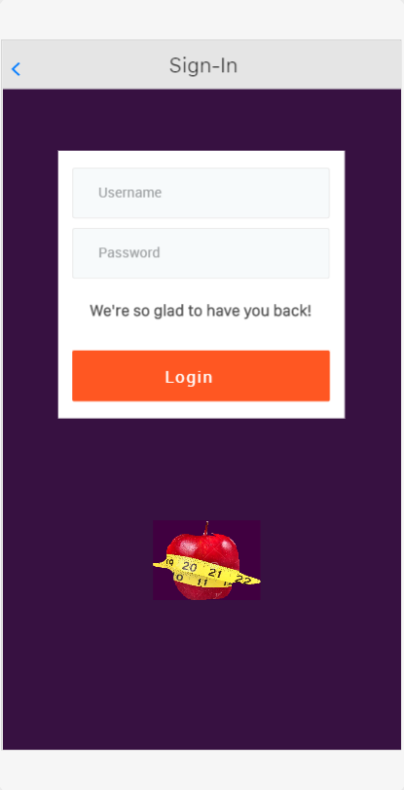

The sign-in screen’s text fields will include “Username” and “Password” inputs for user authentication and access to an account. The “Login” button will not be enabled until both text fields are completed. In the event that both text fields are completed then subsequently erased, the “Login” button will again be disabled. If the username or password are not identified in our user database following user selection of the “Login” button, the “We’re so glad to have you back!” text label will be replaced by a red text label stating “The username and/or password enter does not match any in our records. Please re-enter your username and password.”

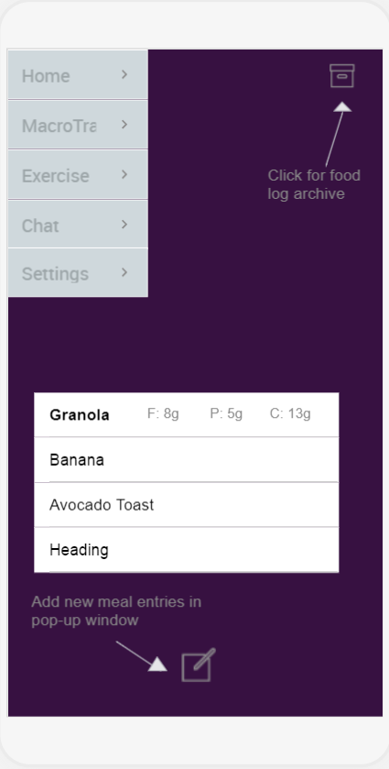

The home screen is defaulted to appear after completion of either the “Sign-In” or “Registration” screens. A menu appears on the left-hand side and has hide/unhide capabilities prompted by swiping with one’s finger, right-to-left and vice versa, respectively. Selection of any of the buttons beneath “Home” will take the user to the appropriate screen. A table view displaying individual meals/snacks and their macro values for that day appear centrally. Selecting one of the table view cells highlights the meal/snack name and displays the fat, protein, and carb content. The upper, right-hand corner offers a selectable button for visiting a calendar display screen that archives past food logs. A compose button appears below the food log and selection of such prompts a pop-up alert to appear (described below).

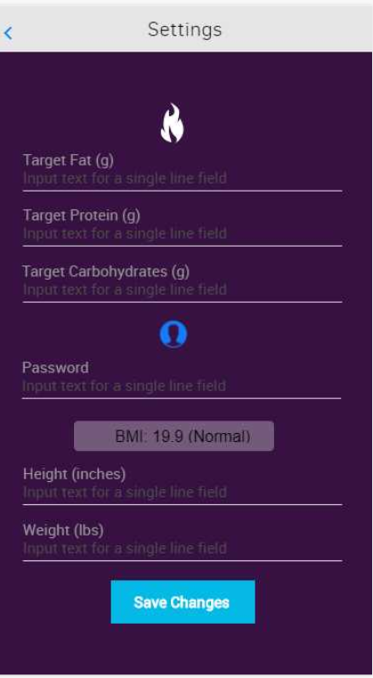

The settings screen will behave similarly to the registration screen in terms of button behavior (“Save Changes” button will only be enabled when all text fields are completed and disabled if one or more such fields are empty; the ability to save changes does not depend on whether or not changes were made). All text fields will be pre-filled with account data last saved for the user following opening the “Settings” screen. A BMI label cannot be edited, but relies on user’s height and weight entries as well as a background algorithm for calculation of BMI. When “Save Changes” is selected *and* a change to “Height” and “Weight” was made, the BMI value will update thereafter on the screen display. Like “Registration,” incorrect ASCII values entered into text fields will be remedied by appearance of red text under the respective fields.

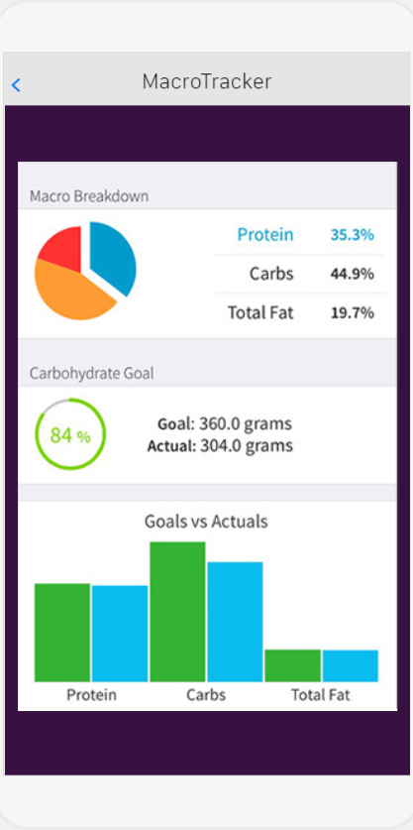

The “MacroTracker” screen relies on data input in the “Settings” screen (i.e. target fat, protein, and carb values) for “Goals” and the home screen’s food log for “Actuals” graphical visualizations, as well as algorithms programmed in the background. There is no user manipulability enabled on this screen; only macro-tracking by visualizations is offered.

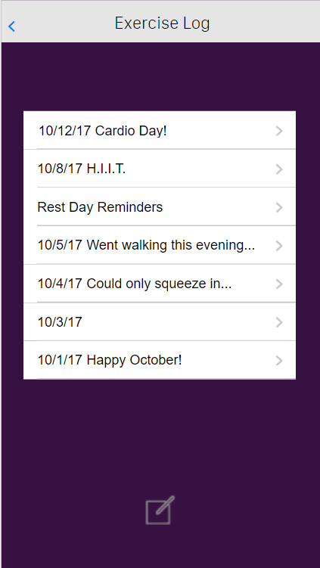

The “Exercise Log” screen will display a limited number of cells in a table view. Scrolling capabilities will be offered. Selecting the compose icon at the bottom of the screen redirects the user to a blank, white screen (similar to Samsung’s “Memo” app) with title and text body input options. The option to return to the “Exercise Log” screen (arrow: upper, right-hand corner) or save a log entry (by button selection) is provided during initial editing. Selection of any of the cells in the table view (following creation and initial saving) will open a similar Memo-like view edited and saved by button selection, or merely viewed. In the upper, right-hand corner, the option to return to the previous screen without saving is offered.

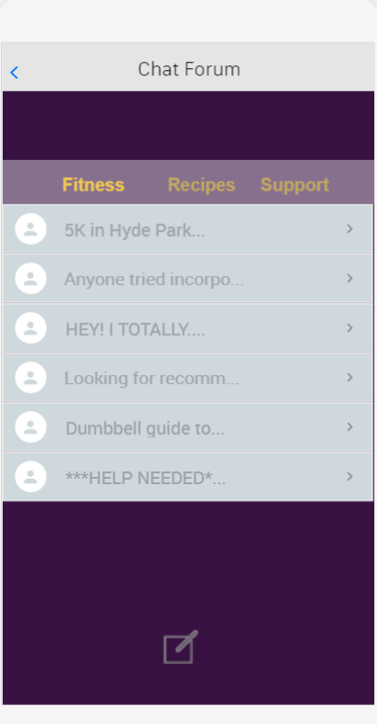

This table view behaves similarly to the “Exercise Log” in terms of making a text entry, but a database will be utilized to store multiple users’ text entries for public viewing by all users in the app. A user can only edit or delete their own entries. Selecting a cell takes the user to that entry’s discrete screen (still, similar to “Memo”). Above the table view, forum genres are listed and are selectable as buttons. A user must be under the genre they wish to post in when selecting the compose icon or to view other entries under that genre.

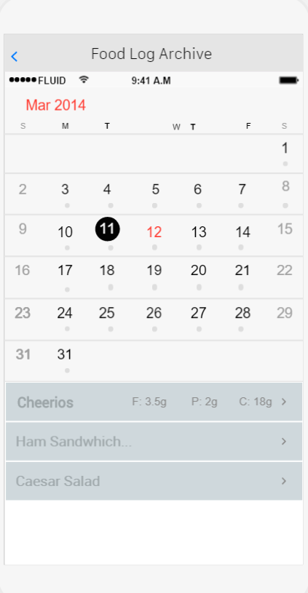

The “Food Log Archive” screen appears as a calendar with selectable dates. Upon selection of a date, the day will be highlighted and that day’s archived food log will appear beneath the calendar. Editing this food log is not enabled, but selecting a cell in the table view highlights the meal/snack name and displays the macro content, similar to the home screen’s food log. Archives are only available for that month to preserve storage space.

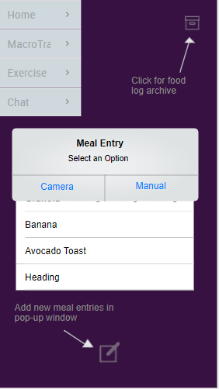

Upon selection of the compose icon located beneath that day’s food log, the user is prompted to select “Camera” or “Manual” buttons as methods of data entry. Selecting “Camera” will redirect the user to the camera screen, and selection of “Manual” will prompt a new pop-up window for entering meal/snack name, fat, protein, and carb content, followed by selection of “Save” or “Cancel” to redirect the user back to the “Meal Entry” alert. A third button labeled “Cancel” will additionally appear on the “Meal Entry” alert to return to the defaulted home screen. A limited number of cells will appear in the food log table view. The ability to scroll down will be enabled for the table view.

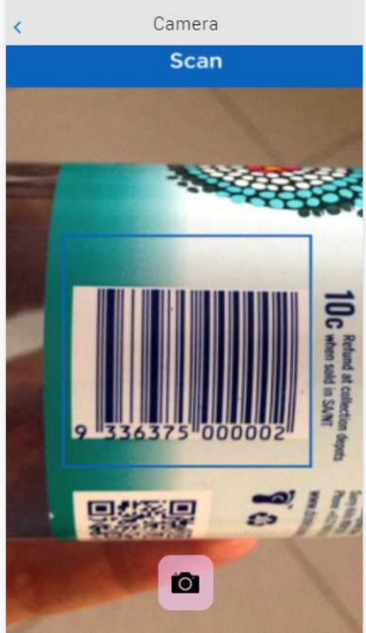

The “Camera” screen enables a user to snap a picture of a prepackaged food’s FDA label (NOT barcode), allowing for scanning of standardized text values for fats, proteins, and carbohydrates. The user must be able to center a scanning window on the entire FDA label for this option to function properly. A camera icon acts as a selectable button once the user feel’s that they’ve centered the scanner and the camera